Database Project — Milestone 3
NASA Exoplanet Explorer — DataFlow Description
Members: Areeba Ali & Syeda Shandana Shah Program: BS Artificial Intelligence
Semester: 4th (B)
Instructor: Sir Ali Hasan

Step 2 — Define Your Dataflow
This section explains where data enters the NASA Exoplanet Explorer system, how it moves through the six database tables, and what comes out. Every detail below is specific to our project schema — no generic descriptions.

2.1 Where Data Enters the System
Our project receives data from three distinct entry points:
Entry Point 1 — NASA Exoplanet Archive (Real Data)
A CSV file was downloaded directly from the NASA Exoplanet Archive containing 6,287 rows of confirmed exoplanet records gathered from space telescopes and ground-based observatories worldwide. After cleaning — removing duplicates, fixing data types, and handling NULLs — this single file was split into three per-table CSVs: Exoplanet (6,286 rows), HostStar (4,708 unique stars), and DiscoveryMethod (11 unique detection methods). All three CSVs were committed to the GitHub repository before database loading.
Entry Point 2 — Python-Generated Synthetic Data
Galaxy, BlackHole, and UserNotes have no suitable publicly available dataset. Python scripts using the Faker library and scientifically plausible value ranges generated realistic synthetic CSV files. These files populated Galaxy (73 rows), BlackHole (70 rows), and UserNotes (100 rows). Galaxy and BlackHole use real astronomical names; BlackHole intentionally leaves 12 galaxy_id values as NULL where the host galaxy is not confirmed — matching the nullable FK constraint in the schema.
Entry Point 3 — User Input via Web Interface
The third entry point is live user interaction. When a user writes a note or marks an object as a favourite on the website, a new row is inserted directly into the UserNotes table in real time. This entry point is distinct from the synthetic UserNotes seed data: the seed data pre-populates the table for demonstration purposes, while real user actions generate ongoing inserts during application use.

2.2 How Data Moves Through the Database
Because the schema uses foreign keys, tables must be loaded in a specific order. Each table that references another must wait until that table is already populated. Loading out of order causes a foreign key constraint error.
Correct Load Order

Order | Table | Depends On | Referenced By | Row Count
1 | Galaxy | Nothing — no FK dependencies | BlackHole (galaxy_id), UserNotes (object_id) | —
2 | HostStar | Nothing — no FK dependencies | Exoplanet (star_id) | —
3 | DiscoveryMethod | Nothing — no FK dependencies | Exoplanet (method_id) | —
4 | BlackHole | Galaxy (galaxy_id) | UserNotes (object_id) | —
5 | Exoplanet | HostStar (star_id), DiscoveryMethod (method_id) | UserNotes (object_id) | —
6 | UserNotes | Exoplanet, BlackHole, Galaxy (object_id) | Nothing — loaded last | —

Table-by-Table Explanation

Galaxy is loaded first because it has no foreign key dependencies. Its galaxy_id values are then referenced by BlackHole (which galaxy a black hole belongs to) and by UserNotes (when a user annotates a galaxy).
HostStar is also loaded in the first batch. Each unique star from the NASA dataset gets one row. The star_id is referenced by every row in Exoplanet to link each planet to its host star.
DiscoveryMethod is a small lookup table with only 11 rows — one per unique detection method in the NASA dataset. It must be loaded before Exoplanet because Exoplanet stores a method_id foreign key for each planet.
BlackHole is loaded after Galaxy. Each row optionally carries a galaxy_id foreign key. Twelve rows have a NULL galaxy_id because the host galaxy is not confirmed for those black holes — the column is nullable in the schema.
Exoplanet is the largest table (6,286 rows) and depends on both HostStar and DiscoveryMethod. Each planet row stores star_id (which star it orbits), method_id (how it was detected), and scientific measurements: orbital period, radius, mass, and equilibrium temperature.
UserNotes is loaded last because it depends on all three object tables. It uses a polymorphic design: the object_type ENUM column records which type of object is annotated (exoplanet, blackhole, or galaxy), and object_id stores the primary key of that specific record. This allows one table to handle user notes and favourites across all three object types without duplication.

2.3 What Comes Out
Query Results
Once loaded, the database answers user search and filter queries across all tables. Examples specific to our schema:
Example Query | Tables / Filters Involved
Show all exoplanets discovered after 2010 using the Transit method | Exoplanet JOIN DiscoveryMethod ON method_id — filter disc_year > 2010 AND method_name = Transit
List exoplanets orbiting stars hotter than 5,000 K | Exoplanet JOIN HostStar ON star_id — filter st_teff > 5000
Show all black holes in the Andromeda galaxy | BlackHole JOIN Galaxy ON galaxy_id — filter galaxy_name = Andromeda
Show a user's saved favourite objects | UserNotes WHERE is_favorite = 1 — then fetch from Exoplanet / BlackHole / Galaxy based on object_type
Export supermassive black holes with confirmed host galaxy | BlackHole JOIN Galaxy ON galaxy_id — filter bh_type = Supermassive, export as CSV
Find exoplanets with equilibrium temperature under 300 K | Exoplanet — filter pl_eqt < 300, export as CSV for habitability analysis

Reports
Beyond single-query lookups, the database is structured to generate analytical reports that summarise trends, distributions, and user behaviour across the full dataset. These reports are generated by aggregation queries and can be rendered in the web interface or exported.
Report Name | Description | Tables Used
Discovery Trend Report | How detection methods have shifted year-over-year from 1990 to present | Exoplanet JOIN DiscoveryMethod — grouped by disc_year and method_name
Star Type Distribution Report | Breakdown of host star types and how many exoplanets each type hosts | HostStar JOIN Exoplanet — grouped by star_type
Black Hole Mass Distribution Report | Mass spread across stellar vs. supermassive categories, with host galaxy data | BlackHole LEFT JOIN Galaxy — grouped by bh_type
User Activity Report | Which objects are most frequently annotated or saved as favourites | UserNotes — grouped by object_type and object_id, ordered by note count

CSV Exports
Filtered result sets can be exported as CSV files for offline analysis or sharing. Example exports include: all confirmed exoplanets with equilibrium temperature under 300 K (habitability candidates), all supermassive black holes with a confirmed host galaxy, and the full HostStar table joined with exoplanet counts per star.
User Annotations
When a user writes a note or marks an object as a favourite on the website, a new row is inserted into UserNotes. The same annotation system works across all three object types (exoplanet, black hole, galaxy) using the object_type and object_id columns — no separate note tables are needed. This polymorphic design keeps the schema clean while supporting all three object types uniformly.
AI Model Inputs
As a BS Artificial Intelligence project, the cleaned database is structured to feed directly into machine learning pipelines. The table below lists the planned ML uses and the exact columns they draw on.
ML Pipeline | Source Table(s) | Columns Used
Habitability Classifier | Exoplanet | pl_eqt, pl_radj, pl_bmassj, pl_orbper
Star Spectral Clustering | HostStar | st_teff, st_rad, st_mass, star_type
Discovery Trend Analysis | Exoplanet + DiscoveryMethod | disc_year, method_name, method_id
Black Hole Mass Distribution | BlackHole + Galaxy | mass_solar, bh_type, galaxy_name, dist_ly

2.4 Dataflow Diagram
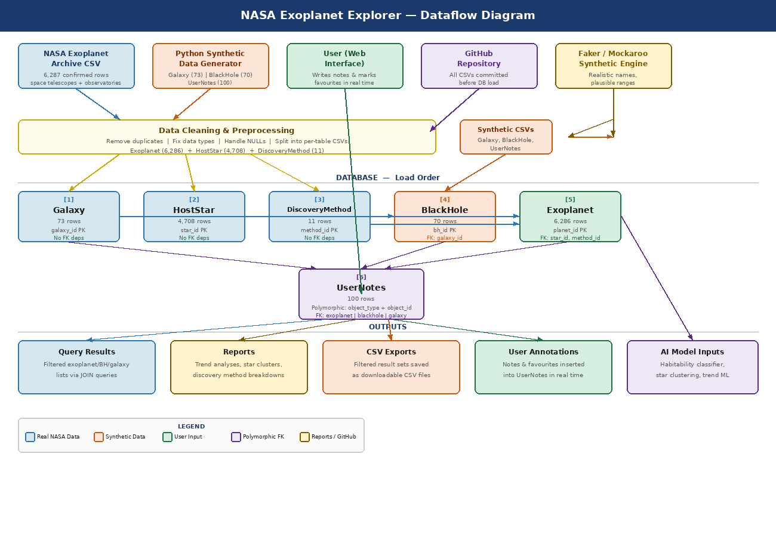
Figure 1 — NASA Exoplanet Explorer: End-to-End Dataflow

